**PRICE APPROVAL (Business central) TASK REPORT**

**I. Purpose**

This document is created to list out the current tasks that have not been completed yet base on the demo date: 2023/05/24.

**II. Task list**

* Approval workflow
  + Sent a approval request – **Completed**
  + Approve/Reject the request - **Completed**
  + Choice Approval Step - **Not Completed –** **See detail**
* Price Approval Page
  + “Add Material” Functional - **Completed**
  + Rich text editor – **Completed**
  + File attachment – **Completed**

**III. List of incomplete tasks**

1. **Select approval step.**

We can select dynamic approval steps in the ACCA Center system, but we cannot do this in Business Central 365 yet. The approval step will depend on the one-time setting by the developer for the approval system.

Picture 1 - Pick the approver for request in ACCA Center

***\* Solution:*** *Due to technical limitations, the developer currently does not have any other solutions.*

**IV. Customized feature with AL Language.**

1. **Approval workflow event**

* I have added a workflow event to the workflow event library.

1. **Materials List**

"Add Material" functional has been added and customized to be like the one on the current ACCA system.

In this section, I have been using Control Add-in to integrate HTML & JavaScript.

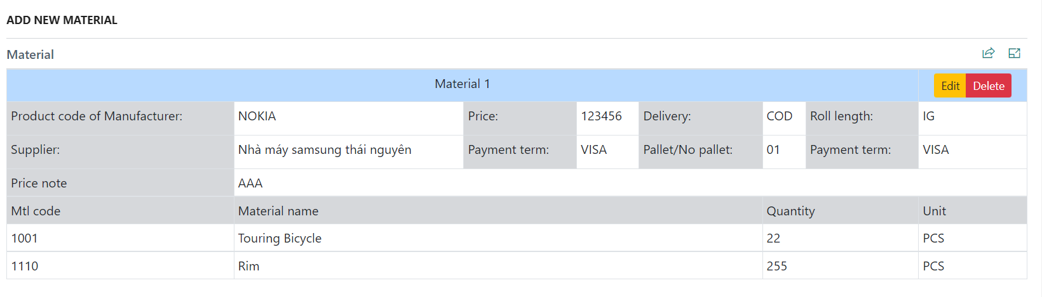

Picture - Add New Material in BC365

Picture - Add new material in ACCA system

1. **Text Editor**

Similar to the 'Add Material' feature, in this section I also utilize a control add-in for text editing. The text editor used here is provided by Summernote.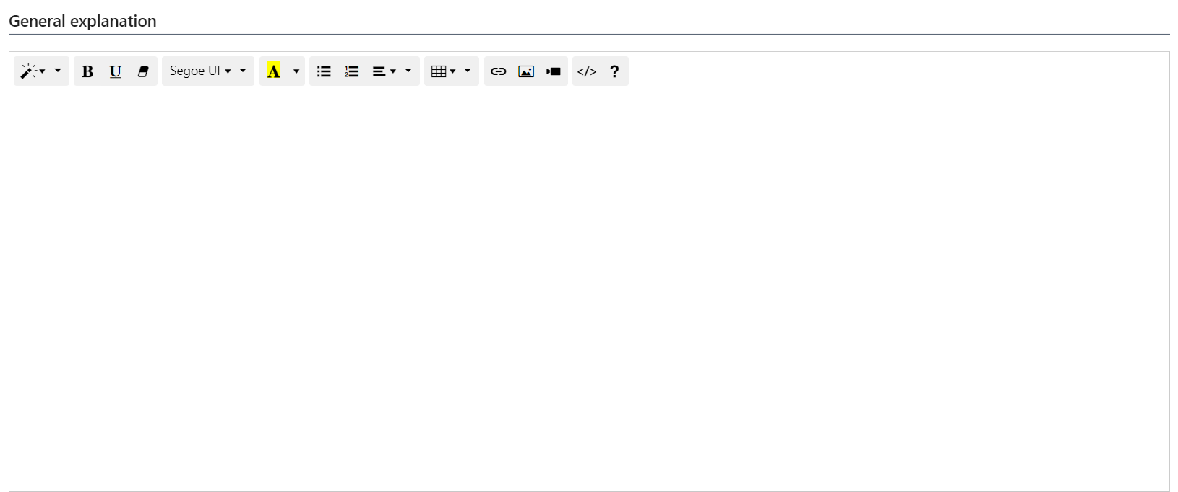

Picture - Control Add-in Summernote Text Editor